Lubbock Reese Redevelopment Authority
EXECUTIVE COMMITTEE Meeting Agenda

Date: Monday, June 18, 2018
Time: 1:00 p.m.
Place: Parkhill Smith & Cooper, 4222 85th Street, Lubbock, TX 79423

----- Agenda Topics -----
AGENDA ITEM | TAB | SPEAKER
Call the meeting to order |  | Jerry L. Bell
- Review Preliminary Fiscal Year 2019 Operating, Fiber Optics, & Capital Expenditure Budgets | TAB 1 | Murvat Musa  Sandy Hamilton
Adjourn the meeting |  | Jerry L. Bell
Lubbock Reese Redevelopment Authority (LRRA) will post this meeting agenda on its front doors and on its website at http://www.reesetechnologycenter.com/index.php/about2/board-meeting-agendas by Thursday, June 14, 2018, 5:00 p.m.

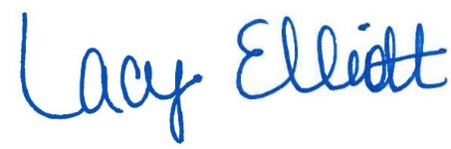

by: _____________________________________
Lacy Elliott, Administrative Coordinator

The LRRA Board meetings are available to all persons regardless of disability. To notify the LRRA of your attendance or if you require special assistance, please contact them at (806) 885-6592 or write Reese Technology Center, 9801 Reese Blvd., Suite 200, Lubbock, Texas 79416 at least 48 hours in advance of the meeting.

